

Prof.
Hammed Tolba Mohamed
Professor of Accounting and Auditing and Former Dean of the Faculty of Commerce – Benha University
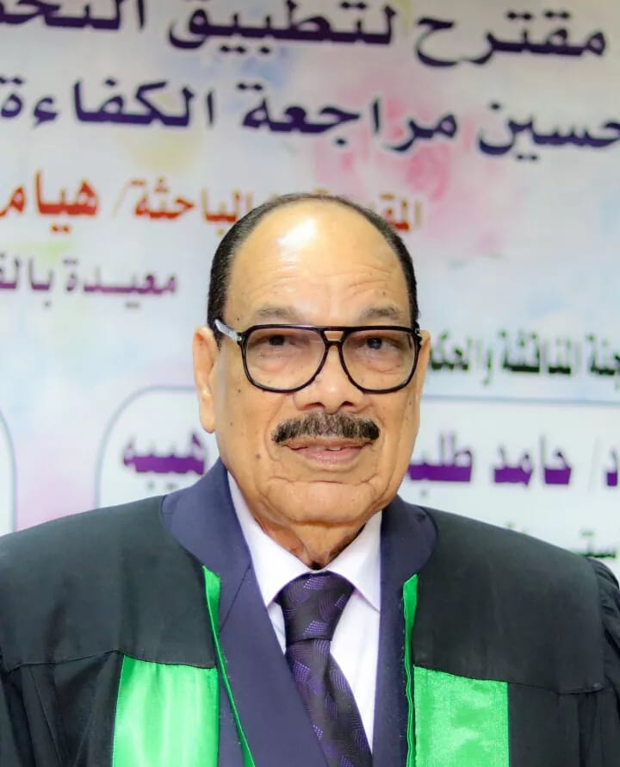
I sincerely thank my esteemed professor, Hammed Tolba, for his invaluable guidance and support, especially during a challenging time. His encouragement and wise advice were crucial to my progress. I dedicate this work to his soul, praying for Allah's mercy and abundant rewards for him, and ask Allah to accept this work as a sincere offering for His sake.

Acknowledgement
First and foremost, all thanks and praise belong to Allah, the Most Gracious, the Most Merciful, for His endless guidance, support, and blessings throughout my journey. I am certain that this work would not have come to fruition without His divine assistance. His guidance has been my constant source of strength, and I remain deeply thankful for His mercy and help in all aspects of my life.
I am profoundly grateful to my supervisors for their unwavering support and guidance throughout the development of this thesis. I would like to express my sincere thanks to Prof. Gehan Abdelhady for her constant encouragement, patience, and valuable insights, which were crucial in shaping my research. Her guidance, detailed feedback on multiple drafts, and willingness to listen to my ideas were instrumental in the completion of this thesis. I could not have asked for a better supervisor.
I also wish to extend my heartfelt thanks to Dr. Wafaa Hegazy for her continuous support and encouragement. Her guidance and motivation were essential throughout the entire research process.
I would also like to express my sincere gratitude to Prof. Eman Saad El-Din for dedicating her time to serve as the external examiner for my Master's thesis committee. I truly appreciate her invaluable contribution.
In addition, I am deeply thankful to Prof. Nasr Taha for sharing his expertise and offering his valuable time as the internal examiner for my thesis.
I would like to extend my heartfelt gratitude to my family, as well as my professors and colleagues at Benha University, who provided me with invaluable support and guidance throughout my Master’s journey. Their thoughtful advice and constant encouragement played a crucial role in helping me navigate challenges and accomplish my goals. I am truly grateful for their kindness and dedication.
The Researcher
Abstract
This study investigates the value relevance of fair value estimates across all levels of the International Financial Reporting Standards (IFRS) 13 hierarchy. It examines how audit quality characteristics - such as audit firm size, audit fees, the use of valuation specialists, auditor rotation, and the timeliness of audit reports - are associated with the value relevance of these estimates. Based on a sample of 438 observations from UK-listed investment funds between 2017 and 2022, the study finds that all levels of the fair value hierarchy are value-relevant to investors, with no significant differences in value relevance across these levels. Additionally, firms audited by Big 4 auditors show higher value relevance for fair value assets across all levels. The study also identifies a positive association between audit fees and the value relevance of fair value assets, particularly for Level 2 and Level 3 estimates. The involvement of valuation specialists has a significantly positive impact only on Level 1 assets, with no significant effect on Levels 2 and 3. Finally, auditor rotation and the timeliness of audit reports do not significantly affect the value relevance of fair value estimates at any level of the hierarchy.
Keywords: IFRS 13; Fair Value Hierarchy; Value Relevance; Audit Quality.

